

Multi-agency Safeguarding Arrangements 2025-2026
Plymouth Safeguarding Children Partnership
pscp@plymouth.gov.uk  www.plymouthscp.gov.uk |  | 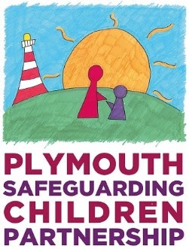
TABLE OF CONTENTS
Introduction & Purpose 3
Safeguarding Partners 5
Relevant Agencies 7
Vision and Priorities 8
Geographical Area 10
Structure and Governance 11
Education & Early Years 12
Links to other partnerships 13
Quality Assurance and Learning 14
independent scrutiny 16
Youth Custody 18
Residential Homes 19
Data and effectiveness 20
Information sharing 21
Multi-agency training 22
Funding 23
Voice of Children, Young People & Families 24
Dispute Resolution & Escalation 25
Building Support 26
Trauma Informed 27
Strategic partnership groups 28
Operational working groups 30
More Information 32

Our shared partnership vision: The right support is available and accessible, at the earliest opportunity, to ensure children and young people in Plymouth are safe and feel safe in their families and communities.

Introduction & Purpose
This document sets out the updated multi-agency safeguarding arrangements in Plymouth, known locally as the Plymouth Safeguarding Children Partnership (PSCP).

Agencies working with children and families across Plymouth recognise that by working in partnership we can achieve more as a collective than we can alone, furthermore, we can best safeguard and promote the wellbeing of our children by harnessing our wide-ranging expertise and resources.

Working Together to Safeguard Children 2023 statutory guidance sets out expectations about how we as a Safeguarding Children Partnership provide help, support and protection for children and their families. It applies at every level, from senior leaders to those in direct practice with families, and across all agencies and organisations that come into contact with children.

The Police, Integrated Care Board (ICB) and the Local Authority must agree and lead local arrangements to work together to safeguard and promote the welfare of all children in their area.

These arrangements will be reviewed annually and take into account any future updates to Working Together to Safeguard Children.

Safeguarding and promoting the welfare of children is defined under Working Together 2023 as:
- Providing help and support to meet the needs of children as soon as problems emerge.
- Protecting children from maltreatment, whether that is within or outside the home, including online.
- Preventing impairment of children’s mental and physical health or development ensuring that children grow up in circumstances consistent with the provision of safe and effective care.
- Promoting the upbringing of children with their birth parents, or otherwise their family network, through a kinship care arrangement, whenever possible and where this is in the best interests of the children.
- Taking action to enable all children to have the best outcomes in line with the outcomes set out in the Children’s Social Care National Framework.

The purpose of multi-agency safeguarding arrangements is to ensure that, at a local level, organisations and agencies are clear about how they will work together to safeguard children and promote their welfare. This means:
- There is a clear, shared vision for how to improve outcomes for children locally across all levels of need and all types of harm;
- When a child is identified as suffering or likely to suffer significant harm there is a prompt, appropriate and effective response to ensure the protection and support of the child.
- Organisations and agencies are challenged appropriately, effectively holding one another to account.
- The voice of children and families combined with the knowledge of experienced practitioners and insights from data, provides a greater understanding of the areas of strength and/or improvement within arrangements and practice.
- Information is sought, analysed, shared, and broken down by protected characteristics to facilitate more accurate and timely decision-making for children and families, and to understand outcomes for different communities of children.
- Effective collection, sharing and analysis of data, enables early identification of new safeguarding risks, issues, emerging threats, and joined-up responses across relevant agencies.
- Senior leaders promote and embed a learning culture which supports local services to become more reflective and implement changes to practice.
- Senior leaders have a good knowledge and understanding about the quality of local practice and its impact on children and families.

It is important that the head of each statutory safeguarding partner agency plays an active role in these arrangements.

Safeguarding Partners
The guidelines identify that Lead Safeguarding Partners (LSP’s) for safeguarding are Chief Executives of Local Authorities, Chief Executives of the Integrated Care Boards (ICBs), and Chief Officers of Police. ‘LSPs are jointly responsible for ensuring the proper involvement of and oversight of all relevant agencies, and should act as a team, as opposed to a voice for their agency alone.’ (Working Together 2023).

In addition, each LSP should appoint a Delegated Safeguarding Partner (DSP) for its agency.
DSPs should be sufficiently senior to be able to speak with authority, take decisions on behalf of the LSP and hold their sectors to account.

In Plymouth we have also ensured there is representation from Education at both LSP and DSP levels, this has been a real strength to our partnership as we appreciate that a vast amount of time for children and young people is spent in an education setting.

Given that the boundaries of the Police and ICB extends over multiple Local Authority areas, a Pan Devon LSP Board has also been established.

Lead Safeguarding Partners (LSPs) have joint and equal responsibility for multi-agency safeguarding arrangements for their Authority. They are required to show strong leadership in overseeing the arrangements to help and protect children.

The LSPs in Plymouth are:
- Chief Constable – Devon & Cornwall Police
- Chief Executive – NHS Devon Integrated Care Board (ICB)
- Chief Executive – Plymouth City Council (PCC)
- Chief Executive – Ted Wragg Academy Trust

LSPs have three functions, these are detailed in Working Together to Safeguard Children 2023.
The functions are to:
- Speak with authority on behalf of their agency
- Commit their agency to the agreed priorities of the Plymouth Children’s Safeguarding Partnership
- Hold their agency to account for the effective delivery of the safeguarding arrangements

LSPs can delegate the three functions to the Delegated Safeguarding Partners who are:
- Chief Superintendent – Devon and Cornwall Police
- Chief Nurse – NHS Devon Integrated Care Board
- Director of Children’s Services – Local Authority
- Director of Safeguarding – Westcountry Schools Trust

Although the functions can be delegated, ultimate responsibility for them remains with the LSPs.

Annually, LSPs will:
- Set the strategic direction, vision, and culture of the local safeguarding arrangements, including agreeing and reviewing shared priorities and the resource required to deliver these Partnership priorities effectively.
- Lead their organisation’s individual contribution to the shared priorities, ensuring strong governance, accountability, and reporting mechanisms to hold their delegates to account for the delivery of agency commitments.
- Review and sign off key partnership documents: published multi-agency safeguarding arrangements, including plans for independent scrutiny, shared annual budget, yearly report and local threshold document.
- Provide shared oversight of learning from performance management and quality assurance auditing, serious incidents, independent scrutiny, local child safeguarding practice reviews, and national reviews, ensuring recommendations are implemented and have a demonstrable impact on practice (as set out in the yearly report)
- Ensure multi-agency arrangements have the necessary level of business support, including intelligence and analytical functions.
- Ensure all relevant agencies, including education settings, are clear on their role and contribution to multi-agency safeguarding arrangements.

Through the agreed Scheme of Delegation, LSPs hold the DSPs to account for:
- The delivery and monitoring of multi-agency priorities and procedures to protect and safeguard children in Plymouth, in compliance with published arrangements and thresholds.
- Close partnership working and engagement with education (at strategic and operational level) and other relevant agencies, enabling effective identification of and response to harm.
- The implementation of effective information sharing arrangements between agencies, including data sharing that facilitates joint analysis between partner agencies.
- Delivery of high-quality and timely Rapid Reviews and Local Child Safeguarding Practice Reviews, with the impact of learning from local and national reviews and independent scrutiny clearly evidenced in yearly reports.
- The provision of appropriate multi-agency safeguarding professional development and learning.
- Seeking of, and responding to, feedback from children and families about their experiences of services.

Relevant Agencies
As well as the three Statutory Safeguarding Partners, we have designated a number of partner organisations as relevant agencies. Although ultimate accountability rests with the three Statutory Partners, the legislation is clear that all agencies share a responsibility for safeguarding children and for working together to achieve that.
The relevant agencies will work with the statutory partners in accordance with these published safeguarding arrangements. Wherever possible, changes to the arrangements will involve consultation with relevant agencies. The relevant agencies in Plymouth include, but are not limited to:

- All early year’s settings
- All Family Hubs
- All primary, secondary, special, further and independent education settings
- Private training providers
- Language schools
- NHS England
- University Hospitals Plymouth NHS Trust
- Livewell Southwest
- Southwest Ambulance NHS Trust
- Adopt Southwest
- Registered fostering agencies
- CAFCASS
- Probation
- Office of the Police & Crime Commissioner
- British Transport Police
- Port and local border police force
- Action for Children
- NSPCC
- Barnardo’s
- Children’s Society
- Young Devon
- First Light
- Community and social housing providers
- Devon & Somerset Fire and Rescue Service
- Ministry of Defence
- Plymouth Argyle Football Club
- Plymouth Albion Rugby Club
- Plymouth Octopus Plus

Vision and Priorities
The PSCP Vision is that the right support is available and accessible, at the earliest opportunity, to ensure children & young people in Plymouth are safe and feel safe in their families and communities.

Our Priorities

The Plymouth Safeguarding Children Partnership has agreed four priority areas.
- Response to Neglect – we want to see an improved early help offer, a reduction in child protection plans for neglect and practice tools implemented effectively to support change with families. We will do this by updating our neglect strategy, implementing the Graded Care Profile 2 and undertaking quality assurance activity to find what is working and where we could do things better.
- Response to Sexual Harm – we want to see improved identification of signs and symptoms of sexual harm, to ensure that when sexual abuse is identified children are effectively safeguarded and to provide improved access to support. We will do this by embedding Together for Childhood learning across the City and implement a strategy to drive change and improvement.
- Response to Domestic Abuse – we want to see improved access to support for child and adult victims, improved access to support for those who cause harm and improved early help offer to prevent escalation of harm. We will do this by strengthening our routine enquiry and assessments and focus on the delivery and impact of intervention.
- Safeguarding Adolescents – we want to see assurance that young people receive support that understands their development needs and the types of harm they may experience. We will do this by reviewing and relaunching the adolescent safety framework and updating our Adolescent Safety Strategy.
- Online Harm – we want to see a better understanding of online harm and its impact on our children and young people. We will do this by incorporating the topic of online harm through all of our subgroups to help identify where this impacts children and how we can improve our city-wide response to this.
- Partnership Visibility – We want to see improved visibility of the partnership in the city so that practitioners and families know how partners can work together to keep children and young people safe. We will do this by improved public facing sharing of information and better communication with all partner agencies including our voluntary sector so that we can share our learning, practice guidance, toolkits and up to date safeguarding information as well as link partners together to improve our shared understanding and shared responsibilities.

The PSCP has agreed underpinning themes and partnership pledges support these priorities:

Underpinning Themes
- Organisational Culture & Professional Support: Underpinning all that we do will be a focus on ensuring the right organisational culture and professional support is in place across all agencies. We know a healthy and stable workforce is key to engaging in the work of our partnership.
- Trauma Informed & Restorative: In all our work, we will understand how trauma shapes the experience of children, families and communities. We will support change with children, families and communities by being restorative, strengths based, and trauma informed.
- Whole Family Approach: We will always work ‘with’ families and adopt a ‘family first’ culture and approach to help keep children safe, happy and at home.

Geographical Area
The Plymouth Safeguarding Children Partnership (PSCP) will cover the City of Plymouth and these multi-agency safeguarding arrangements shall be based upon the Plymouth Local Authority boundaries.
It is recognised that the ICB covers both Devon, Torbay and Plymouth Local Authority areas and that the ‘footprint’ of Devon and Cornwall Police, covers all of the County of Devon and Cornwall.

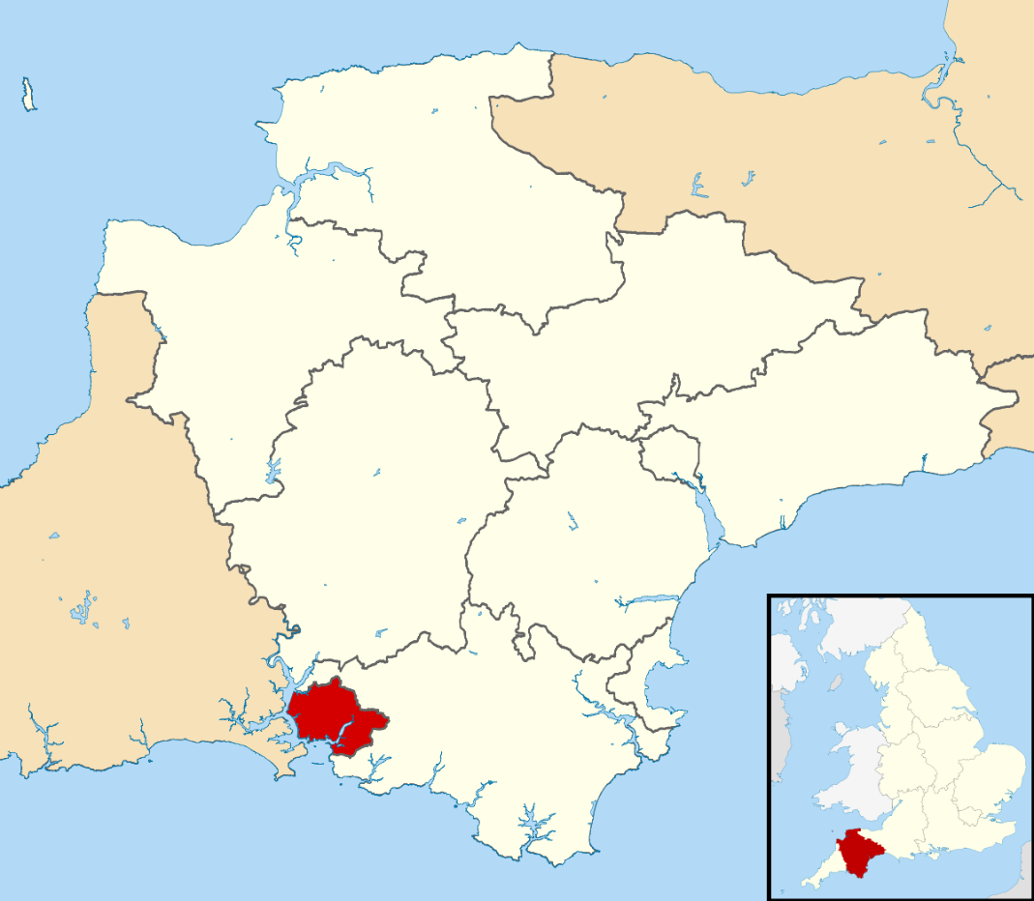

Structure and Governance
Structure of the PSCP: 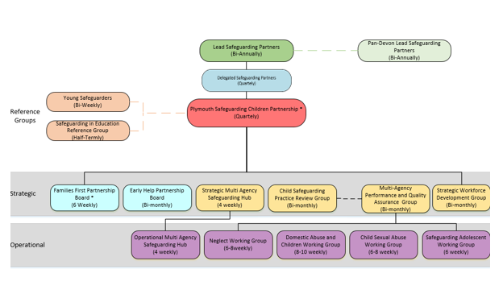

Education & Early Years
In Plymouth, we recognise the valuable strengths of our education partners who spend a huge amount of time with our children and young people.
Under Working Together 2023, we have raised the profile of Education within our partnership and have an education representative at Lead Safeguarding Partner (LSP) level and Delegated Safeguarding Partner (DSP) level. We also ensure all our partnership subgroups have education representation.
We have a Safeguarding in Education Reference Group (SERG) where representatives from the education sector come together to discuss current practice in relation to safeguarding and share information from the other partnership groups, including updates in relation to Prevent, information on new training offers through the PSCP and current themes and trends in relation to safeguarding adolescents.
The partnership manager and other partner agency representatives also regularly attend the Designated Safeguarding Lead (DSL) meetings to ensure education partners are appraised of current partnership work and emerging themes in safeguarding.


Links to other partnerships
The Plymouth Safeguarding Children Partnership (PSCP) has been structured to meet the requirements of Working Together to Safeguard Children 2023.
The groups of the PSCP will bring together relevant agencies across Plymouth who will drive the safeguarding priorities set by the PSCP, ensuring that its core and statutory functions are delivered.
The PSCP will deliver local dynamic responses to confidently create, influence and negotiate system improvement as part of multi-agency working and deliver effective working relationships that improve impact and outcomes for their children and young people.

The PSCP arrangements have been established in the context of wider partnership and governance arrangements across Plymouth. The PSCP arrangements link into other strategic partnership work streams that support children, young people and families. Such partnerships include, but are not limited to:
  - Health and Wellbeing Board
  - Community Safety Partnership
  - Domestic Abuse Sexual Violence and Violence Against Women and Girls Board
  - Safeguarding Adults Board
  - Channel Panel
  - Multi-Agency Public Protection Arrangements.
It will also continue to work collaboratively across the Southwest Peninsula.

Quality Assurance and Learning
A learning culture is paramount to enable a constant cycle of positive change for safeguarding children, young people and families in Plymouth and it is our responsibility as a Partnership to examine safeguarding practices across our partner agencies so that we can develop and continuously improve to provide the best outcomes for all.

Child Safeguarding Practice Reviews
We have a multi-agency Child Safeguarding Practice Review (CSPR) group in Plymouth who decide the process for a Rapid Review or full CSPR and ensure internal guidance is created for us to implement learning quickly after a child has suffered significant harm. The decision for a Rapid Review is mutually agreed by senior representatives of the statutory organisations. Should this proceed National Panel are notified before a rapid review process begins, facilitated by the CSPR group where the report is submitted to National Panel with a recommendation for next steps. Should a further LCSPR or CSPR be needed the CSPR group and business unit work together through the processes held by the CSPR group for this. When we complete a full CSPR the learning from this is published on our PSCP website.

Learning from Experience Reviews
We have decided as a Partnership that if the criteria is not met for a CSPR, but there is still learning to be gained to enable system change and better outcomes for children in the future, a Partnership Learning from Experience Review will be convened. This enables all organisations involved in a child’s life to come together to discuss their agency and joint agency involvement so that practice areas that need to be strengthened are identified and a practice improvement plan is agreed which are overseen by the CSPR group. This provides a robust level of scrutiny to enable better learning.

Quality Assurance Audits
At least four times a year our Multi-Agency Performance and Quality Assurance Group (MAPQAG) arranges multi-agency audits of our practice with children based on topics agreed within the yearly workplan which are identified using referral data, emerging themes and national learning. The PSCP audit tool is used to capture the child’s experiences with each service and how the agencies are working in partnership. The audits are a helping tool to support the identification of what is working well and what practice needs to be strengthened. A Practice Learning Review meeting is then arranged so that the practice patterns and themes identified within the audits can be discussed and actions can be identified for practice improvements. All agencies are involved in leading the Practice Learning Reviews. A one-page learning briefing is produced which is circulated across the Partnership with the actions plan. The relevant partnership working group takes responsibility for progressing the actions. This quality assurance arrangement provides a reliable evidence base to enable actions to be identified for practice improvements. To close the loop and evidence difference made, the MAPQAG work plan sets out a repeat of the same quality assurance activity so that progress with practice improvement actions can be evidenced.

S.175/157 Schools’ Safeguarding Audits
Education providers are required to ensure their safeguarding policies and procedures are up to date and in line with legal requirements. The S.175/157 audit process uses questions to education providers to identify gaps in their safeguarding and can also highlight safeguarding emerging themes. The audit questions are created in conjunction with the education participation and skills team in Children’s Services and the MAPQAG.

S.11 Audits
The PSCP undertakes Section 11 audits, in line with The Children Act (2004) to ensure the PSCP partners are fulfilling their responsibilities to safeguard children and promote their welfare. These are carried out individually with each agency as a reflective audit process.

Domestic Abuse Related Death Reviews
The PSCP has close links with the Community Safety Partnership (CSP) in Plymouth where Domestic Abuse Related Death Reviews (DARDR’s) are completed as multi-agency learning reviews following the murder or suicide of a victim of domestic abuse. Multiple partners from our safeguarding children system take part in these reviews and any learning is disseminated amongst partners and actions monitored by the Domestic Abuse and Sexual Violence board.

Annual report
The PSCP is required under Working Together 2023 to undertake a review of the effectiveness of its arrangements and its progress on its priorities. This will inform a retrospective annual report (April to March in line with business year cycle) which will be published on the PSCP website by the end of September of each year.
The annual report can be found on the PSCP website here:

https://plymouthscb.co.uk/annual-report/

independent scrutiny
Delegated Safeguarding Partners have decided Independent Scrutiny will be completed in priority areas through the use of multiple scrutineers and including our Young Safeguarders as one of the scrutineers.
The Plan for Independent Scrutiny for 2025 and 2026 can be found below.

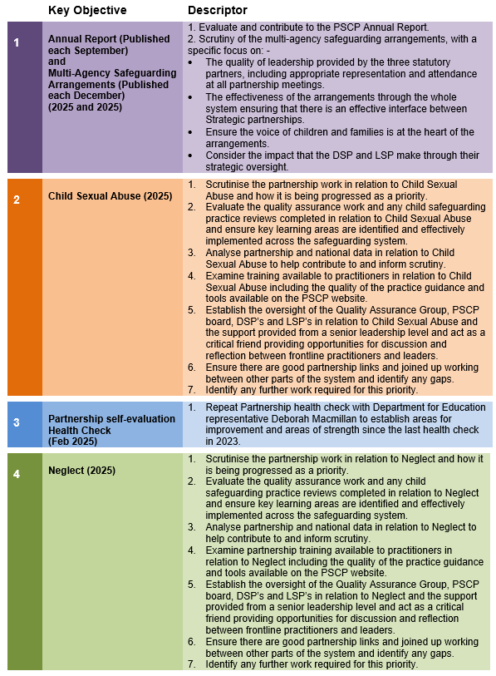

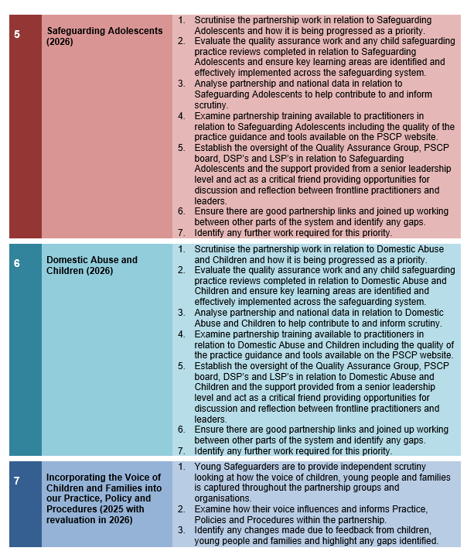

Youth Custody
There is currently no youth custody within Plymouth; however, where children are taken into youth custody or secure accommodation elsewhere, they will be subject to oversight by the Youth Justice Service, within Plymouth City Council.
The Youth Justice Service is represented by Plymouth City Council across all groups and will be included in relevant quality assurance and scrutiny activity.

Residential Homes
Plymouth has one fully registered Children’s home, Downham House, which offers a short break service for children with severe learning disabilities and associated complex behaviours, to enable them to continue to live within their family home.

Plymouth is currently developing the offer to include further children’s homes. Part of this offer will be specialist short breaks for children with complex health and physical disability to enable families to continue supporting their children at home. The other part of this offer is in the form of two 3 bedroom homes for children in care, aged between 6 and 18, in partnership with our health and fostering services.

Data and effectiveness
To enable the early identification of new safeguarding risks and issues the partnership have a data scorecard, which is scrutinised through the audit work of the Multi-agency Performance and Quality Assurance Group, by the Young Safeguarders and at the Partnership Board. The data is resourced multi-agency and we have recently recruited a data analyst to analyse the data and build a more comprehensive dashboard based on the Durham Data Model which has been recognized at a leading model for the analysis of safeguarding data. This is expected to be completed in full by June 2026 in preparation for this dashboard to be shared with peninsula partnerships to create a clearer picture across the peninsula of the safeguarding need.

Information sharing
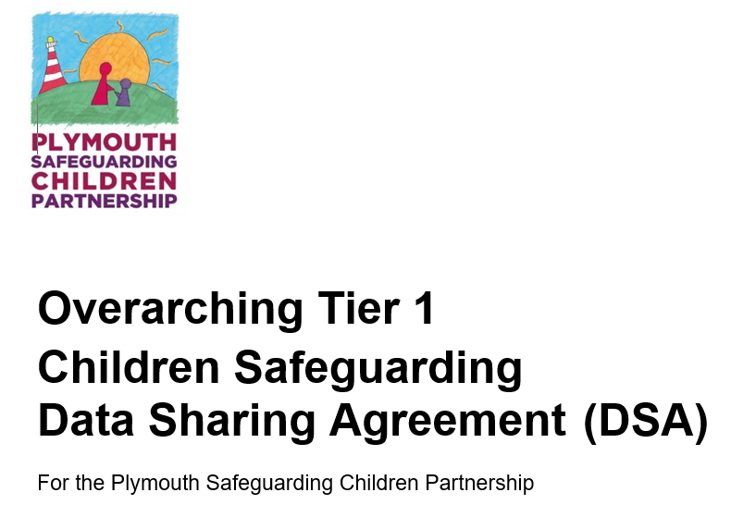
In Plymouth in 2024 we worked closely with Department for Education leads, Somerset and our own partners to create a new Data Sharing Agreement which is available on the PSCP website here:

https://plymouthscb.co.uk/pscp-data-sharing-agreements/

In 2026 we will be adding to this Data Sharing Agreement with the creation of Tier 2 models which will support the implementation of the Families First Partnership Reforms.

Multi-agency training
The strategic oversight and development of the partnership’s workforce development is by the workforce development subgroup, overseen by the partnership board.
The workforce development group meets bi-monthly and will be responsible for:
- Development of a Plymouth wide training programme ensuring training is responsive to local needs.
- Development of a consistent charging policy for training.
- Responding to Plymouth wide learning needs, such as responding to local and national safeguarding practice reviews and reports.
- Plan for the annual PSCP conference, drawing from local and national learning to decide theme and approach.
- Coordination of communication on Plymouth learning themes.
- Identifying any learning which can be shared through the PSCP website.
- Development of an approach to evidence impact of training on practice.
- Reporting progress annually via the partnerships’ annual report with updates quarterly to the PSCP board highlighting any risks and issues.

Funding
- LSPs agree funding arrangements for the multi-agency arrangements for safeguarding and promoting the welfare of children.
- The expenses of the PSCP business unit will be met from the budget.
- The budget must be sufficient to cover statutory responsibilities and core PSCP business delivery.
- Local decisions on budget expenditure are delegated to the DSP’s and PSCP board.
- The local authority hosts the business unit activity and is therefore responsible for ensuring each partnership’s fiscal compliance and governance.
- The annual report will set out Lead Partner contributions to the budget and a summary of expenditure.
- Expenditure decisions will be made in accordance with local agreements and schemes of delegation.

Voice of Children, Young People & Families
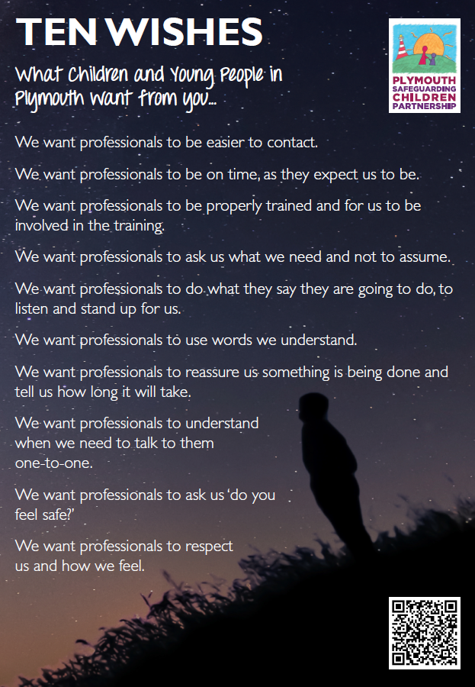
Plymouth has a group called Young Safeguarders. This is a group of young people from across the city who work to make sure that the lived experience and voices of children and young people are heard and that information that is produced, such as the policies and procedures that affect their lives, are fair and understandable. They meet fortnightly and are supported by the Plymouth City Council Participation Team, with costs part-funded by the PSCP. They provide regular scrutiny of the PSCP, including a quarterly review of our data scorecard.

Previously, The Young Safeguarders produced The Ten Wishes, and these were embedded in the PSCP multi-agency training programme. They have since been updated and relaunched.

More information about the Young Safeguarders can be found on the PSCP website here:

www.plymouthscb.co.uk/young-safeguarders-2.

Dispute Resolution & Escalation

Effective safeguarding of children is predicated on practitioners and frontline staff wanting the very best for children and being ready to stand up in their best interests even if this brings them into disagreement with other practitioners, with other organisations or with their own managers and employing bodies. We have a clear case resolution and escalation process for the PSCP to assist should this be the case called “resolving professional differences”.

The resolving professional differences protocol can be found on our website here:

https://plymouthscb.co.uk/resolving-professional-differences/

In the event of a disagreement between the three Lead Safeguarding Partners an Independent Person may be asked for advice to help partners swiftly and transparently reach a suitable resolution. The LSPs and/or DSPs may also seek independent advice, for example legal advice when appropriate. Partners will ensure throughout any dispute that their focus remains on safeguarding the child.

Building Support

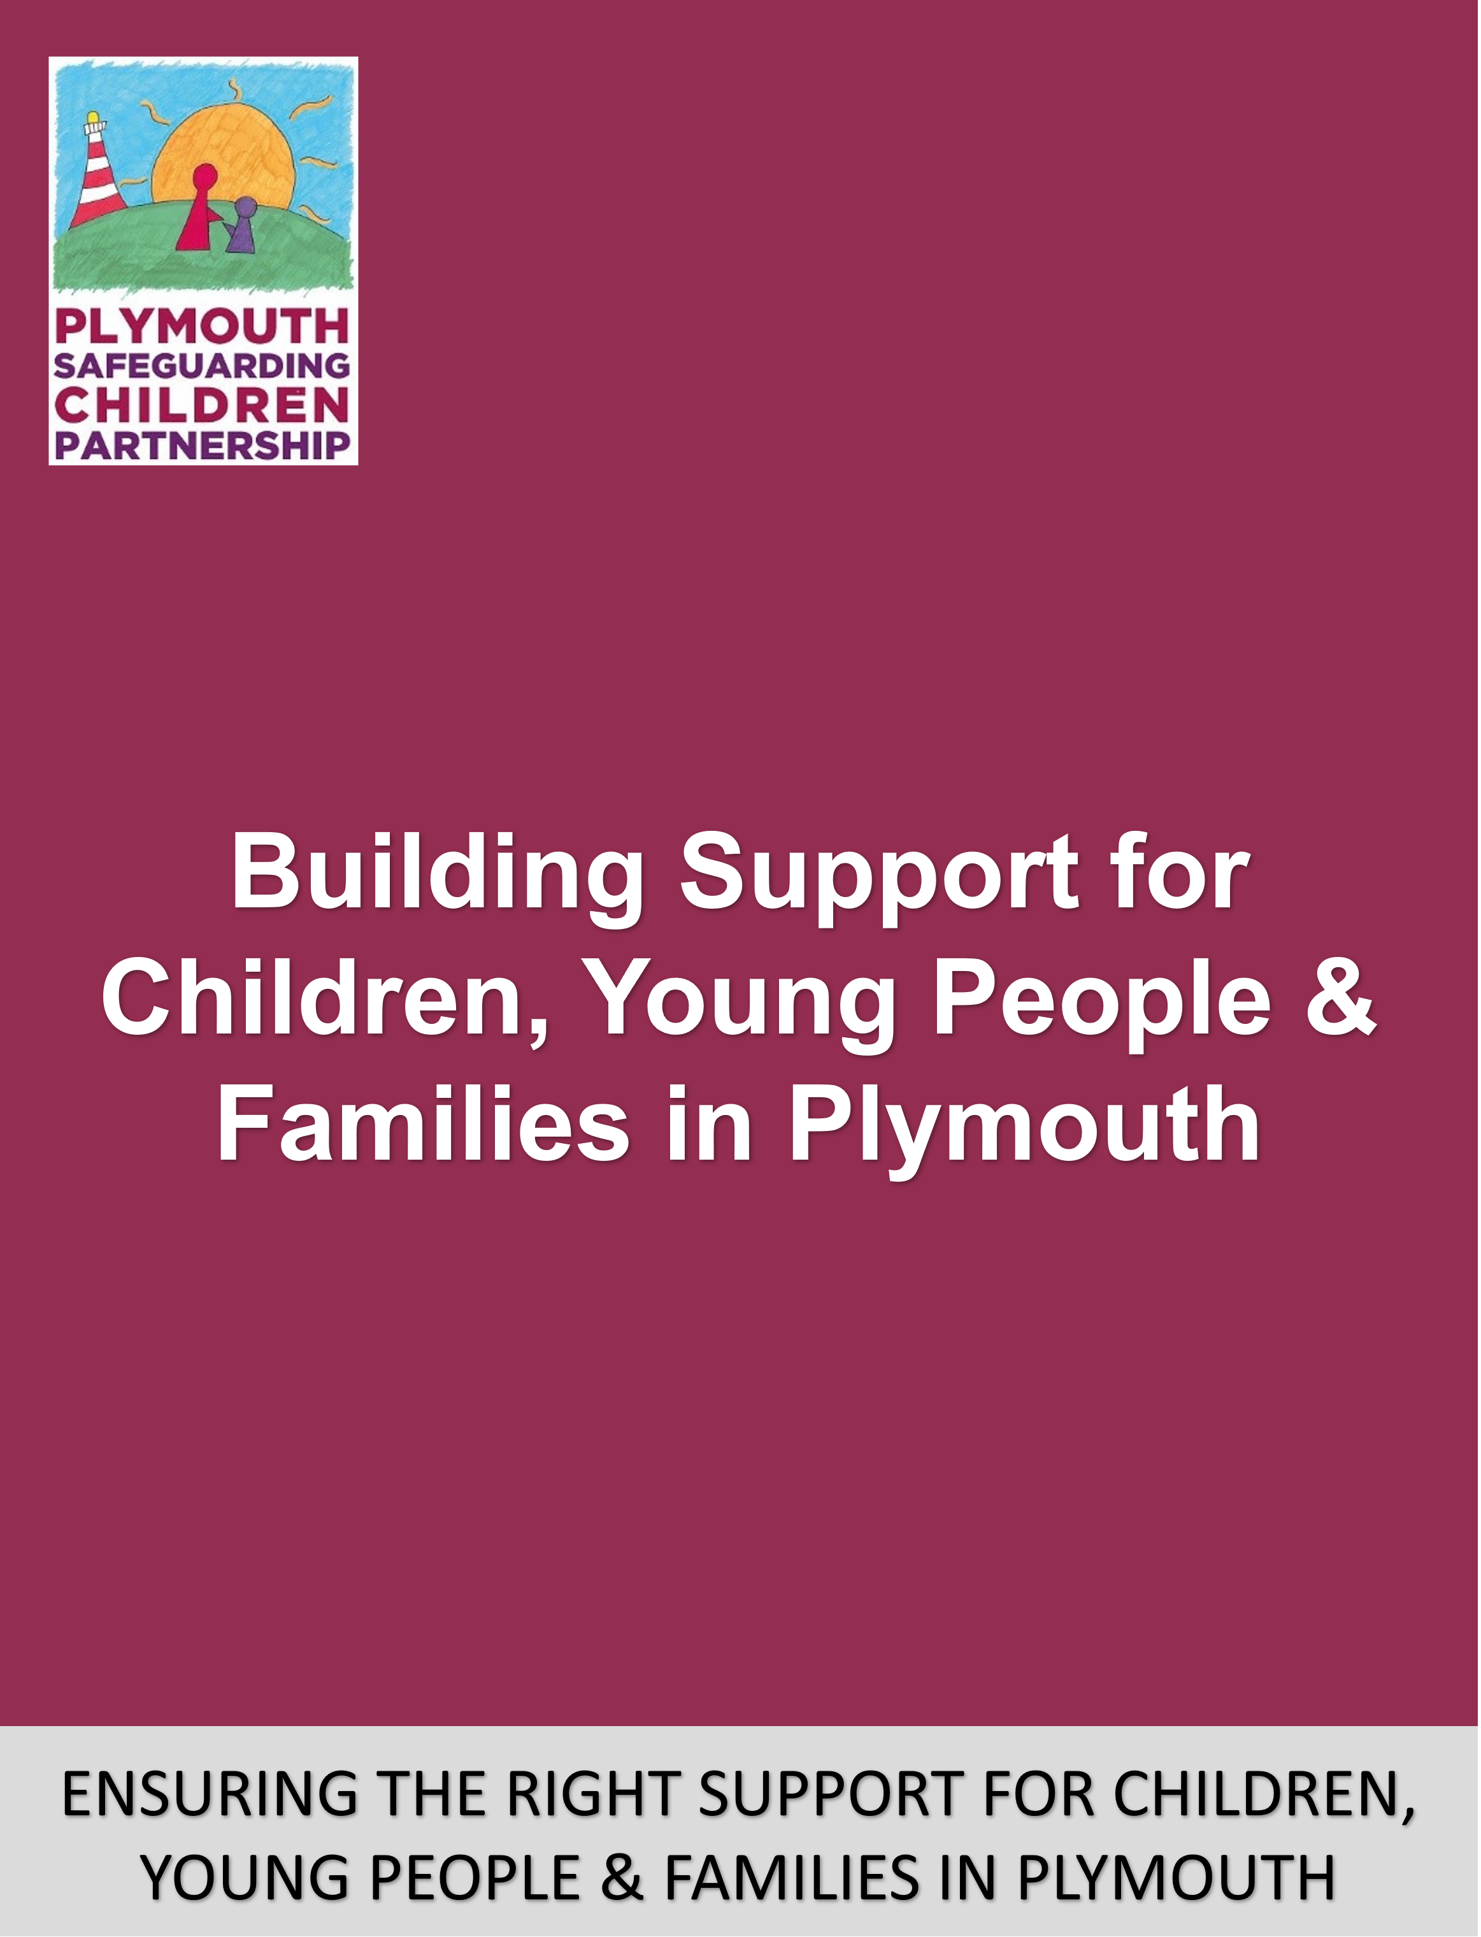
Building Support is the agreed Partnership framework for how we understand the different levels of need families experience and how we work together with families to support children and young people, including where there are safeguarding concerns.
During August and September 2023 the original document and approach, first launched in April 2022, was reviewed, which aimed to more clearly illustrate ‘thresholds’ and provide more detailed content on information sharing and consent.

You can find the Building Support guidance and professional enquiry workshop video on the PSCP website here:

https://plymouthscb.co.uk/building-support/

the Building support framework will be updated in early 2026 in line with the implementation of the Families First Partnership Reforms.

Trauma Informed
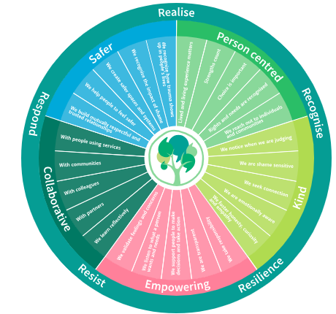
The PSCP ensures that trauma informed practice is maintained and will apply the trauma-informed lens in its work by using the Trauma Informed Plymouth Network principles.
This means that throughout its arrangements the PSCP shall ensure that it supports the 5 core values for a trauma informed Plymouth:

Safe: there is consideration of the psychological safety of those involved in and impacted by its safeguarding arrangements. When meeting, engaging and working with children, young people, families, communities and professionals all efforts shall be made to establish trusting relationships.

Person centred: understanding the lived experience of children, young people, families and communities and the circumstances which led to their involvement within services. Voices of the child, young person, families and
communities shall be listened to and heard with respect.

Collaborative: children, young people, families, communities and professionals are treated as equal partners in the PSCP safeguarding arrangements. Learning shall be reflective with openness and emotional awareness.

Empowering: there is an overriding expectation that the PSCP safeguarding arrangements will make a genuine difference. All involved, engaged or working within safeguarding services deserve to know that their contributions have influenced real change and that the PSCP is going to ensure that learning from their involvement, engagement or work is meaningful and widely disseminated.

Kind: ensure that language is appropriate and mindful of victim blaming or falling into judgement. There will be understanding that traumatic circumstances may evidence behaviour that is considered challenging, and the trauma lens shall be applied to try to understand the underlying cause of this. There shall be kindness, clear transparent and compassionate communication and engagement.

Strategic partnership groups
Multi-Agency Performance and Quality Assurance
Chaired by Children’s Services
Meets Bi-monthly.
This group will:-
- support the creation and delivery of our Quality Assurance and audit activity and monitor performance of partnership activity.
- pass actions from reviews to the working groups and receive assurance when these are completed.
- provide assurance to the PSCP board and strategic safeguarding partners that children and young people in Plymouth are being adequately safeguarded.
- where safeguarding arrangements are less than satisfactory, this group should be aware, alert the wider Partnership to any issues identified as well as providing recommendations for how things could be improved.

Child Safeguarding Practice Review
Chaired by Health
Meets Bi-monthly (unless meeting for a current review)
This Group will:-
- in accordance with Working Together 2023 and any guidance issues by National Panel initiate a local Child Safeguarding Practice Review in serious safeguarding cases where
  - abuse or neglect of a child is suspected and
  - the child has died or has been seriously harmed.
- deliver and oversee local Child Safeguarding Practice Reviews to identify improvements in safeguarding practice and protecting children from harm and make actions from recommendations for improvement and assurance to the Multi-Agency Performance and Quality Assurance Group which will pass these actions to the relevant Working group.

Workforce Development
Chaired by the Learning and Development Lead of the Business Unit
Meets Bi-monthly
This group will identify and deliver against the learning needs of the multi-agency workforce by:
- undertaking an annual training needs analysis.
- Ensuring the PSCP is offering a diverse and high quality training delivery programme that meets the identified safeguarding learning needs.
- Supporting the implementation of learning that results from national and local reviews/events.
- Delivering recommendations from the PSCP.
- Considering emerging practice issues and respond accordingly.

Strategic Multi Agency Safeguarding Hub
Chaired by Police
Meets monthly
This group will work as a partnership to provide multi-agency strategic direction for the MASH and to hold the MASH operational group to account for performance and quality assurance objectives against agreed objectives.

Operational working groups
Child Sexual Abuse
Chaired by Children’s Services
Meets Bi-monthly
- This group will co-ordinate our multi-agency approach to Child Sexual Abuse and will be reporting into the DASV and VAWG partnership board within Safer Plymouth and into the Plymouth Safeguarding Children Partnership.
- The group will be responsible for developing performance measures and monitor multi-agency effectiveness with regards to CSA following any audit and learning review recommendations from the PSCP.
- The group will have an overview of workforce development relevant to CSA utilising the purpose-built practice guidance and toolkit and reading across to the Workforce Development partnership group.
- The group will be responsive to emerging issues – for example from local and national safeguarding reviews, audit work or Ofsted reports.

Domestic Abuse and Children
Chaired by Health
Meets Bi-monthly
- This group will co-ordinate our multi-agency approach to Domestic Abuse and Children reporting into the DASV and VAWG partnership board within Safer Plymouth and into the Multi-Agency Performance and Quality Assurance Group within the Safeguarding Children Partnership.
- The group will be responsible for developing performance measures and monitor multi-agency effectiveness with regards to DA and children following any audit and learning review recommendations from the PSCP.
- The group will have an overview of workforce development relevant to DA and children utilising the purpose-built practice guidance and toolkit and reading across to the Workforce Development partnership group and DASV board.
- The group will be responsive to emerging issues – for example from local and national safeguarding reviews, audit work or Ofsted reports.

Neglect
Chaired by Action for Children
Meets Bi-monthly
- This group will co-ordinate our operational multi-agency approach to Neglect.
- The group will be responsible for delivering on actions and recommendations identified through any audit and learning reviews within the PSCP.
- The group will utilise the purpose-built practice guidance and toolkit and help implement the neglect strategy.
- The group will identify and implement performance measures to support QA work and the strategy.
- The group will be responsive to emerging issues – for example from local and national safeguarding reviews, audit work or Ofsted reports.
- The group will have read across other safeguarding groups, including the quality assurance delivery group for QA work in the area of neglect and the workforce development group for training opportunities.

Safeguarding Adolescents
Chaired by Police
Meets Bi-monthly
- This group will co-ordinate our operational multi-agency approach to Adolescent Safeguarding.
- The group will be responsible for delivering on actions and recommendations identified through any audit and learning reviews within the PSCP.
- The group will utilise the purpose-built practice guidance and toolkit and help implement the safeguarding adolescent strategy.
- The group will identify and implement performance measures to support QA work and the strategy.
- The group will be responsive to emerging issues – for example from local and national safeguarding reviews, audit work or Ofsted reports.
- The group will assist with the implementation and embedding of the new Adolescent Safety Framework process.
- The group will have read across other safeguarding groups, including learning actions being tasked by the Multi-Agency Performance and quality assurance delivery group for QA work in the area of safeguarding adolescents and the workforce development group for training opportunities.

More Information
Annual Report
We publish an annual report that contains up to date information on the work of the PSCP, our funding arrangements for that year and our priorities for the year ahead. This can be found on our website: www.plymouthscb.co.uk/annual-report.

Resolving Professional Differences
This protocol can be found here: https://plymouthscb.co.uk/resolving-professional-differences/
Thresholds
Our response to the requirement for a threshold document can be found here: www.plymouthscb.co.uk/building-support/

PSCP Website
More information about what we do and the difference we are currently making, can be found on our website: www.plymouthscb.co.uk.

Young Safeguarders
Information about the Young Safeguarders can be found on the PSCP website here: www.plymouthscb.co.uk/young-safeguarders-2.

Information Sharing
The PSCP Multi-agency Data Sharing Agreement is available on the website here: https://plymouthscb.co.uk/pscp-data-sharing-agreements/

