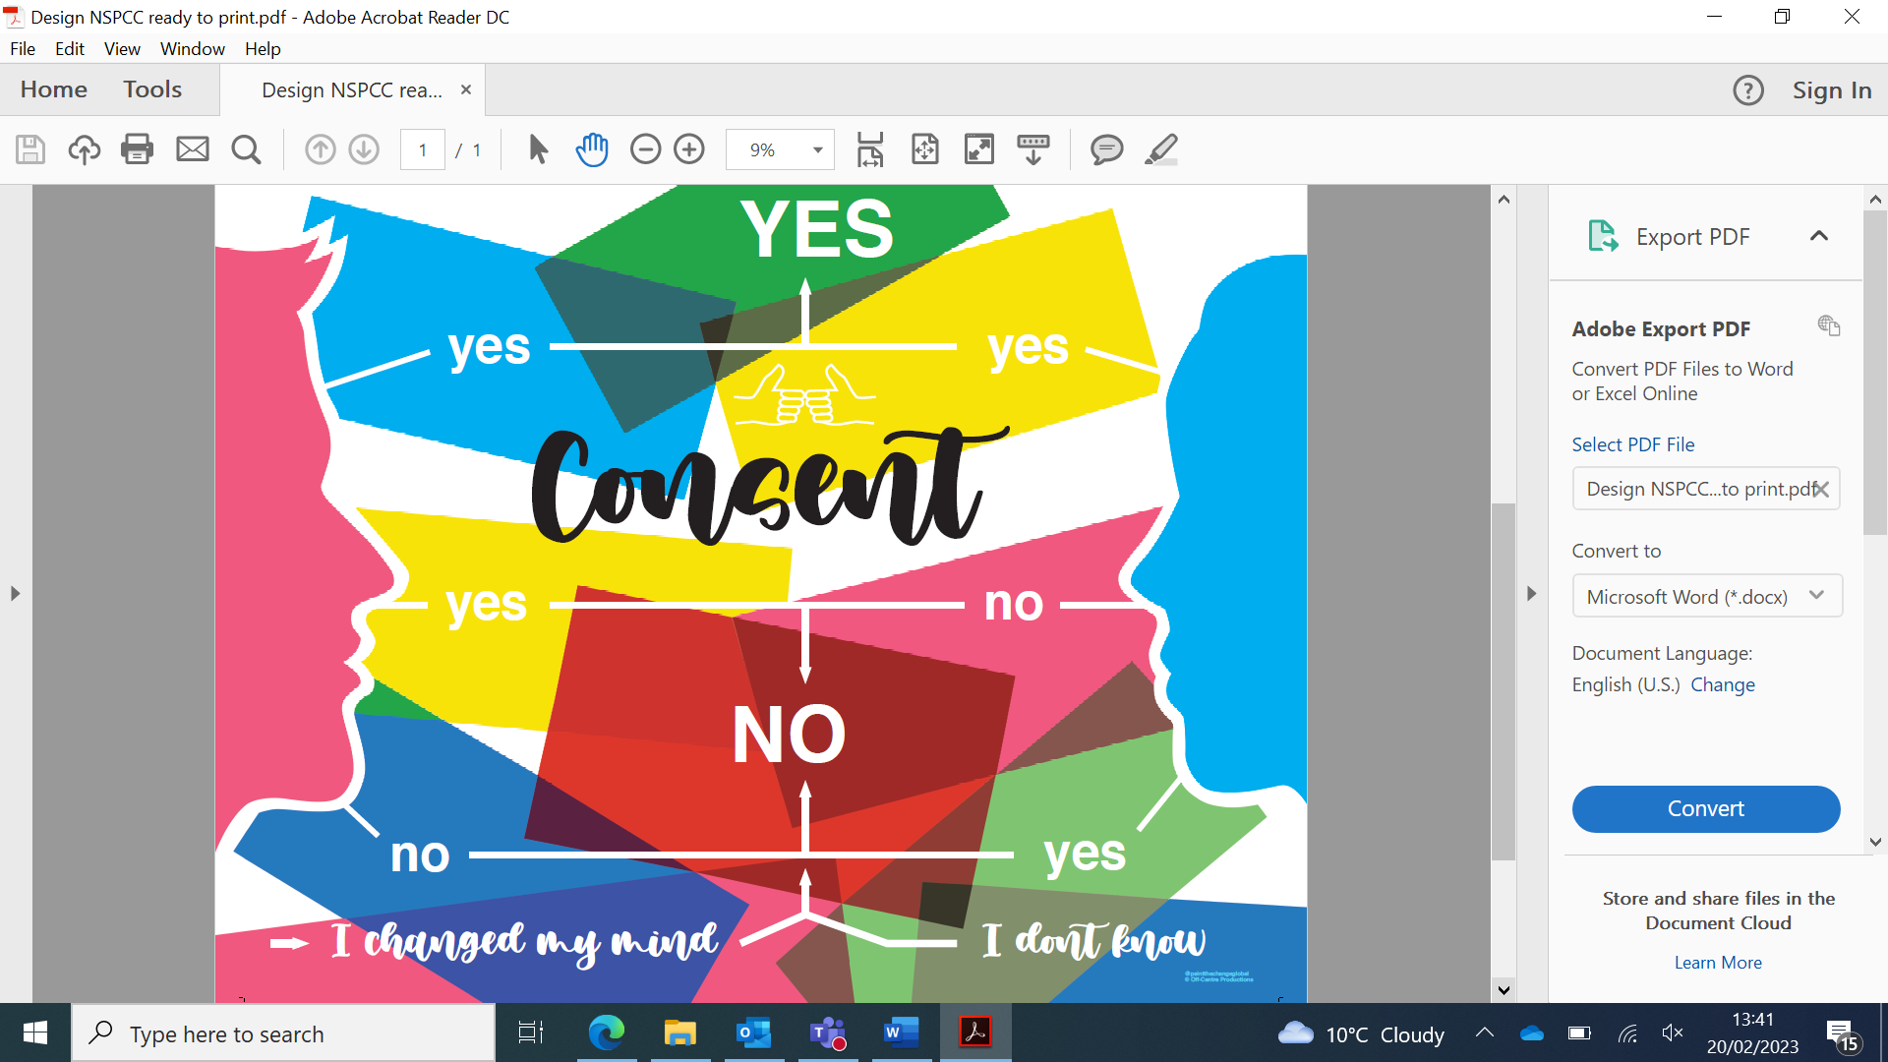

This puzzle is based on a mural designed by a group of post 16 students from Mill Ford school. The group discussed the subject of consent in school, and wanted to create something bright and colourful to remind them of these discussions. The original is painted in one of the school classrooms.

The group also wanted a way to make the mural into something interactive, so they created this puzzle, with the view that it could be used as a conversation starter to talk about consent. The puzzle shows that consent is a decision that two people fully understand and both agree to. It shows that they are able to make a choice about whether they want to participate or not (and can change their minds) – like the pieces of a jigsaw coming together to make a whole. Consent applies to any relationship, not just a sexual relationship.

Together for Childhood would like to encourage you to use this puzzle as a conversation starter about consent and healthy relationships with your young person.

You know your child best, and how to best communicate with them. However, if you are unsure about how to approach the subject of consent and healthy relationships, here are a few questions you might want to ask while completing the puzzle together:

- What’s your understanding of the word “consent”?
- Do you feel comfortable saying “no” to people, even friends?
- Do you think it’s ok to change your mind, even if you’ve already said yes?
- If you felt pressured or uncomfortable, who would you talk to?

Don’t worry if the person they would talk to isn’t you; the important thing is that they have someone they feel comfortable to talk to.

If you’d like further information about how to talk to your child about health relationships, please visit the NSPCC website www.nspcc.org.uk

