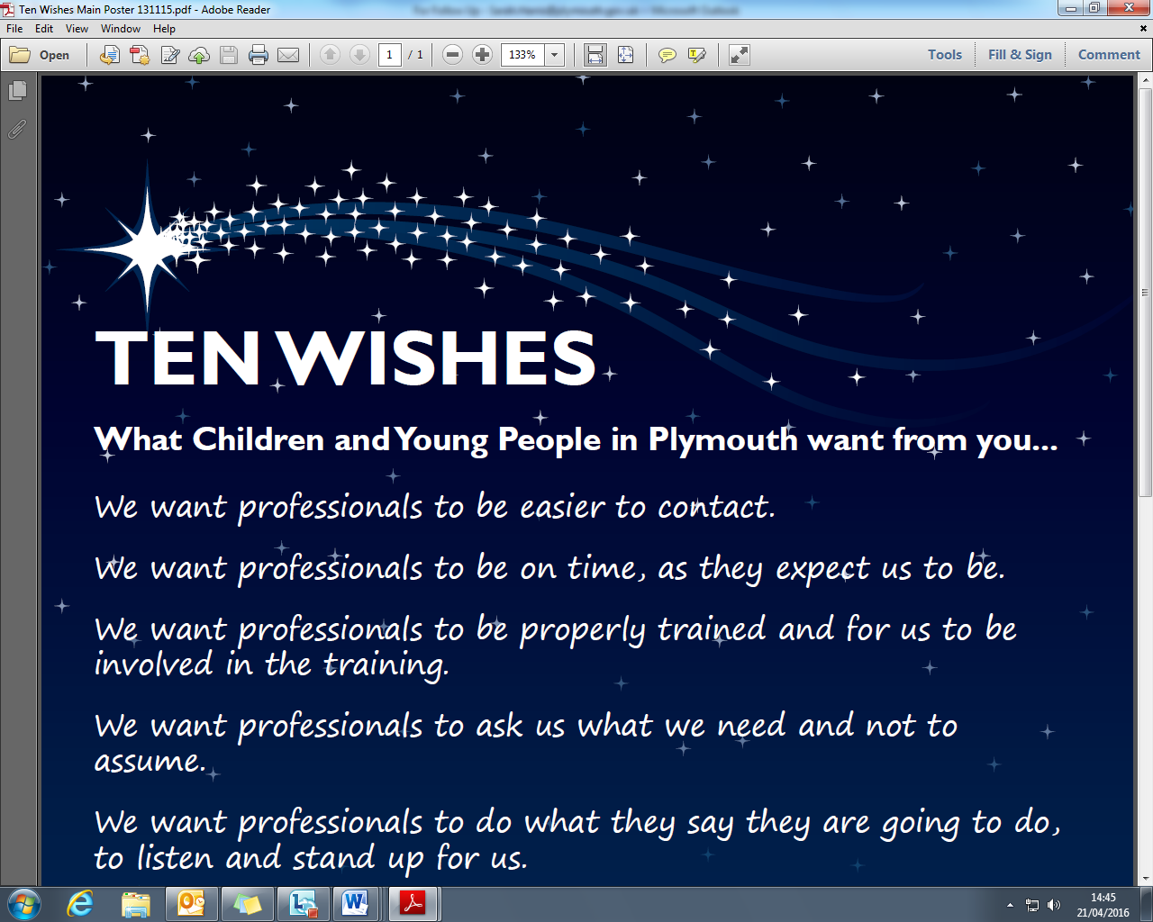

**Agency name:**

**Date completed:**

|  |  |  |
| --- | --- | --- |
| **Wish** | **Agency Commitment**  What is your commitment to young peoepl in relation to this wish? | **Agency Update**  What’s changed? Have your plans worked? If you haven’t started, how do you plan to achieve this? How can you tell this has made a difference to young people? |
| **WISH 1**  We want professionals to be easier to contact. |  |  |
| **WISH 2**  We want professionals to be on time, as they expect us to be. |  |  |
| **WISH 3**  We want professionals to be properly trained and for us to be involved in the training. |  |  |
| **WISH 4**  We wantprofessionals to ask us what we need and not to assume. |  |  |
| **WISH 5**  We want professionals to do what they say they are going to do, to listen and stand up for us. |  |  |
| **WISH 6**  We want professionals to use words we understand. |  |  |
| **WISH 7**  We want professionals to reassure us something is being done and tell us how long it will take. |  |  |
| **WISH 8**  We want professionals to understand when we need to talk to them one-to-one. |  |  |
| **WISH 9**  We want professionals to ask us ‘do you feel safe?’ |  |  |
| **WISH 10**  We want professionals to respect us and how we feel. |  |  |